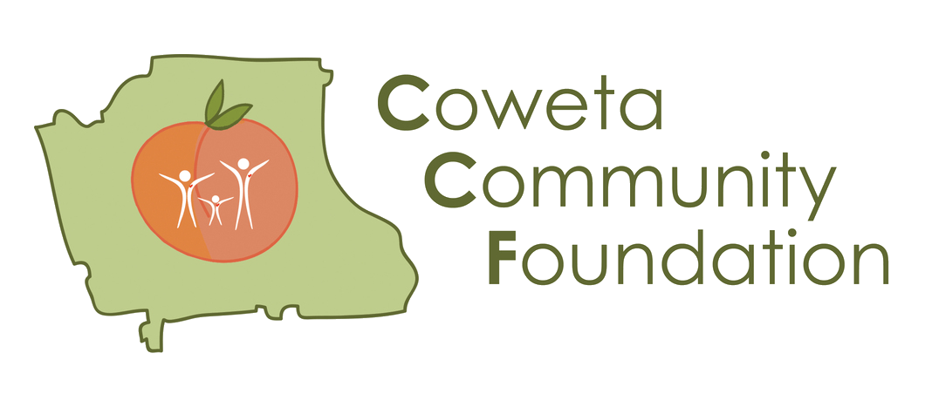 | Grant Application  Program Implementation Work Plan

Using the table below, please outline the activities that will be most important in achieving your proposed objectives. Your completed Work Plan will show us: (1) what you are doing and when, (2) who is responsible for implementing the project, (3) costs associated with each proposed objective, and (4) the results you expect from each of your activities. You may add or delete rows as necessary.

Organization: [Please type your organization’s name here] Requested Grant Amount: [Enter amount here] Program Budget: [Enter amount here]

Objective  The direct, tangible, and measurable result you are seeking to achieve (one objective per row). | Action  How the project will be put into action to achieve each objective (you may enter more than one activity per row, as each objective may have multiple activities associated with it). | Timeframe  The start date and end date of the period during which each activity will occur. | Responsible Person  The person who is accountable for each project activity. | Financial Projection  Use of CCF Grant Funds  What will the requested grant funds be used for to achieve the costs associated with this objective? | Financial Projection Your Organization’s Contribution  What is your organization contributing toward the costs associated with this objective? This is not required match but encouraged | Proposed Measures of Success  How the success of the project will be assessed in reaching the objective. | Outcomes  What will be different if you successfully implement this project?
You may add rows to this chart as needed.

